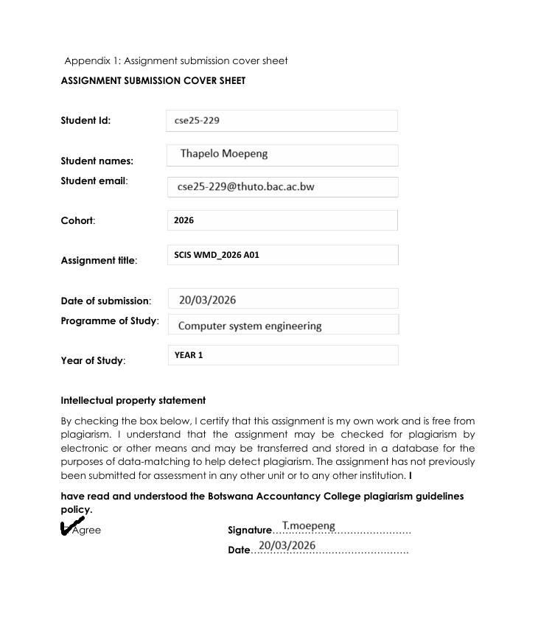

Part A – Website Specification Document
Task 2
- Website Specifications:

- State the website objective, its goals in relation to the business.

The main objective of the website is to:

- To showcase different places of attractions in Botswana which may attract tourists to visit the country of Botswana and this will eventually help boost the generation of revenue in the department of tourism.

- As more tourists are attracted, this would help local businesses such as hawkers, retailers, hotel owners and tour guiders generate more income through selling local products and providing services such accommodation and tour guides.

- State the target audience, showing their demographics and technical aptitude.

Demographic

- Age: 16+ years
- Gender: Both male and female
- Location: Local and international tourist
- Income level: People who afford to travel

Technical aptitude

- Mostly people who use mobile phones and social media
- People who can Browse Through the website and search information

- You must identify the type of website or content you will be designing for the users

- This is a website that will be providing information about tourism across the country of Botswana.
- It will also show major cultural events that take place annually and explain their significance.
- It would also showcase different cultural information of different cultures in Botswana (Food, music, traditions).
- Provide Images and videos of places of attraction in Botswana.
- This website well provide awareness on safety precautions, travel guidelines and tips to tourists planning to visit places of attraction in Botswana

- Information Design & Taxonomy:
Information Design
- Home page: Introduction and highlights of tourism
- Destination page: Tourist sites which are reserves, cities, pans, national parks, historical sites and wetland/delta
- Culture page: Food, music, tradition and events
- Activities page: Safaris, adventures and water activities
- Gallery page: Photos and videos of tourism in Botswana
- Travel information page: Transport, Safety tips and guidelines, best time to visit

Storyboard flowchart
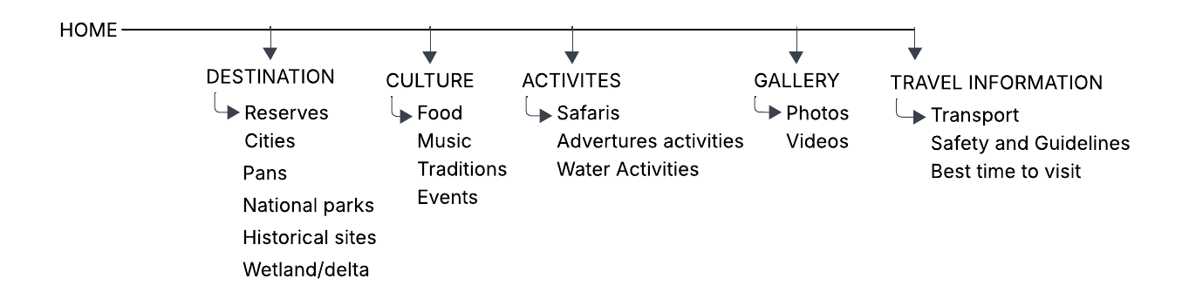
- Page Template Design:

- Description of page template

- Header: Contains the websites logo and title
- Navigation bar: Menu links (Home/LOGO button, Destination, culture, activities, gallery and travel information), moto and search button.
- Main content area: Displays information, images and text.
- Footer: Logo, quick access links and copyrights.

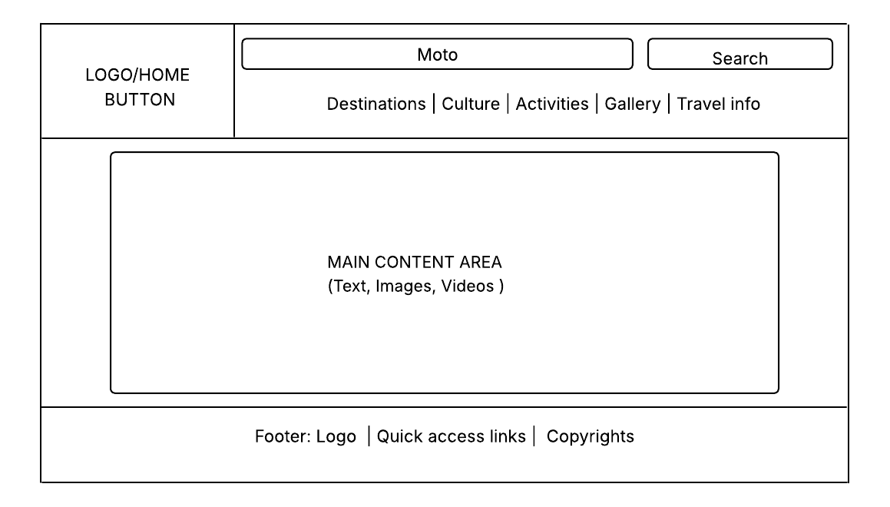

4.Technical Brief:

- Technologies to be used:

- HTML – to check the structure of the web pages
- CSS-to design and style the website layout

- Software tools

- VS code-for writing code
- Chrome-for testing and viewing the website
- Github-for storing and managing the websites files

